Name: _____________________________ Homeroom: ___________ Date:________
Unit Test #2 Study Guide: Structure of Matter
Part I: Defining and Measuring Matter

- In order for something to be matter, it must have _____ and ______________.
- What measuring tool is used to measure mass?
- What measuring tool is used to measure the volume of a liquid?

- What is the volume of the rock pictured to the right?

Part II: All Matter is Made of Atoms
- Define atom in two ways:
- The building block of all ____________
- The smallest part of an _______________ that still retains all of the __________________ of that element

- Fill in the entire table below of the three subatomic particles.
Subatomic Particle | Charge | Location
 | Positive
Neutron

- What do Cam Newton, Mr. Cody, glacier freeze Gatorade, and an orange pen have in common (other than the fact that they are all awesome!)?

Part III: Elements vs. Compounds
For the following write E for Element or C for Compound:

- Water
- H₂O₂ (rubbing alcohol)
- Hydrogen
- Oxygen
- Contains chemical bonds between two or more different atoms

- CaCO₃ (chalk)
- 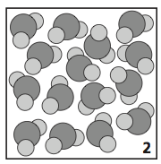
- ZnO (sunscreen)
- HCl (stomach acid)
- NaCl
- (CH₃)₂CO (Fingernail Polish Remover/Acetone)

- NH₃ (Windex)
- Chemical symbol
- Chemical formula
- Is unable to be divided further by physical or chemical means

- Has subscripts (If you change the subscript, you change the ratio. If you change the ratio, you change its properties completely!)

- Is made up of ONE TYPE of atoms

Part IV: Compounds vs. Mixtures
For the following write C for Compound or M for mixture:

- C₁₂H₂₅SO₄Na (Soap)
- NaCl (Salt)
- 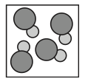
- NaHCO₃ (Baking Soda)
- Our air
- Dental amalgam (combo of silver & mercury)

- 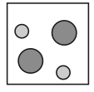
- 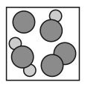
- Fresh-squeezed lemonade
- 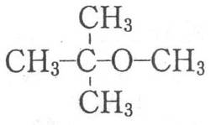
- C₁₂H₂₂O₁₁ (Sucrose Sugar)
- Saline solution
- Rust formed on a old fence
- 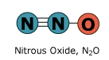

Fill in the missing blanks in the following chart:
 | Compound | Mixture
Are they made of atoms?
Combination of: | Two or more DIFFERENT elements
How are they combined? |  | Physically
Contain chemical bonds?
Separated by:
Are they completely new substances?
Does changing the ratio change the substance? |  | No. Mixtures are not formed using a specific and definite ratio.
 | Compound | Mixture
Do original properties of substances change? | YES! Compounds are new substances! Therefore, they will have new properties. These properties may or may not be similar to the properties of the elements that make them up.
Additional notes | Abbreviated by chemical formulas | Classified as homogeneous or heterogeneous

Part V: Drawing Models (of Atoms, Elements, Compounds and Mixtures)
- Draw the Bohr model for element fluorine (F).

- Draw an atomic model for the element fluorine (F).

- Draw the atomic arrangement for NaF (Toothpaste-Colgate)

Part VI: The Chemical Make-Up of Our Atmosphere
Answer the following questions completely about Earth’s atmosphere.
- Earth’s atmosphere is a mixture of _________.

- Which gas makes up most of the Earth’s atmosphere?

- Approximately what percentage of Earth’s atmosphere is made up of oxygen?

- Approximately what percentage of the Earth’s atmosphere is made up of nitrogen?

- Two gases make up nearly 99 percent of Earth’s atmosphere. What are they?

- What is the most abundant gas in Earth’s present atmosphere?

- Draw the atomic arrangement for the mixture of gases in our atmosphere.

- Label the following pie chart with the correct gases that make up Earth’s atmosphere:
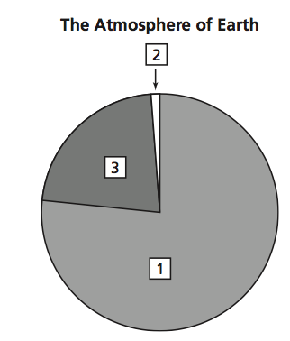

9. Fill in the table below with the appropriate percentages for the following gases:
Gas | Chemical Symbol/Chemical Formula | Element or Compound? | % of Earth’s Atmosphere
Hydrogen | H₂ |  | >1%
Oxygen | O₂
Neon | Ne |  | >1%
Methane | CH₄ |  | >1%
Krypton | Kr |  | >1%
Nitrogen Oxide | N₂O |  | >1%
Argon | Ar |  | >1% (~.93)
Nitrogen | N₂
Helium | He |  | >1%
Carbon Dioxide | CO₂ |  | >1%(~.033)
Ozone | O₃
Xenon | Xe |  | >1%

WHAT CAN YOU BE DOING TO “OWN IT”?
- Work hard! Hard work coupled with perseverance and smart choices are the biggest factors in determining your future.
- Study our Cornell notes so we can rock it and top it!
- See Coach C or reach out to a peer for tutoring if you need extra help.
- If you understand this, push yourself to higher levels: learn more and help your friends.
- Apply what you are learning to the real world! This information is EVERYWHERE around us. I mean, come on, all matter is made of atoms!

GOOD LUCK!!!

