Name: ____________________________ Homeroom: _________ Date: _________ 4.6
Counting the Number of Atoms & Recognizing Balanced Equations (SPI.9.11)

Key Point | Notes
Chemical Reaction Code | 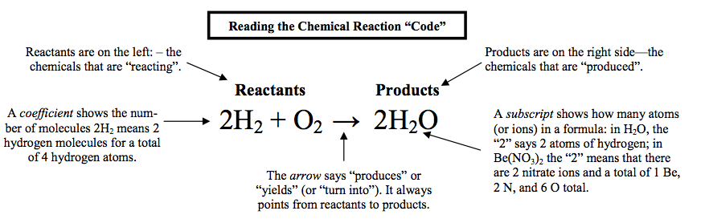
Subscript | - A subscript is whole number (decreased in font) that comes ________ a chemical symbol.  - A subscript only corresponds to the ___________ that it immediately follows  - If there is not a subscript written, a subscript of _____ can be assumed  - A subscript is used to tell the number of _____ in EACH ____________ in a compound
Coefficient | - A coefficient is a whole number comes in _________ of the element or compound, never in the middle!  - You ___________ the coefficient to ____ the numbers in the compound  Ex: 3AlCl₃  How many atoms of each element do you have?
Following the Law of Conservation of Mass | Chemical reactions MUST follow the law of conservation of _______.  What was that LCM again?  - The mass of the products will equal the mass of the reactants  - There must be the same number of ________ at the beginning and _______ of chemical reaction.  - If 3 carbons are in the ___________ of a reaction, then there darn well better be 3 carbons in the products of a reaction.  - No new atoms are ________ and none of the original atoms are destroyed. As a result, the mass of the reactants and the products is the ______.
Balanced Equations | - In order to follow this law, every chemical equation must be a balanced chemical equation.  - Two things must be balance:  - ______  - ________  - The number of _______ of each element on the reactants side must _________ the number of atoms of each element on the products side!  - We change ___________ to balance equations!  - With proper coefficients, the equation now adds up! This gives us a ___________ equation.
So What?!
“I Own This” (Independent Practice):
- Calculate the number of atoms of each element in the following:
- 2HgO
Element | # of atoms
c. 2AlCl₃
Element | # of atoms
d. 4H₂O
Element | # of atoms
e. 6H₂O
Element | # of atoms
f. 5KCl
Element | # of atoms

2. Calculate the number of atoms for each element on each side of the equation and decide if the equation is balanced.
a. 2HgO 2Hg + O₂
Element | # of Atoms on left | # of atoms on right
Hg
O
Is the equation balanced?

b. Zn + HCl ZnCl₂ + H₂
Element | # of Atoms on left | # of atoms on right
Is the equation balanced?

c. Fe + O₂ Fe₂O₃
Element | # of Atoms on left | # of atoms on right
Fe
O
Is the equation balanced?

“Own It Even Further” (Early Finisher):
Try to balance the equations above that were not balanced OR work on your Lab Report!

