Name: _____________________________ Homeroom:_________ Date: ________ 4.5
Does that Break the Law of Conservation of Mass?! (SPI.9.11)

Key Point | Notes
Where did the mass go? | - Sometimes in a chemical reaction, it seems like mass has been destroyed. It HAS NOT!  - This is often because _______ have been _____________ into the air  - The mass of the reactants have not disappeared  - The mass of the products will still be exactly equal to the mass of the _______________!  Combustion reaction:  - A combustion reaction occurs when _________ from the air combines with another substance  - During combustion reactions:  _______ are released into air  ______ and/or _______ is given off  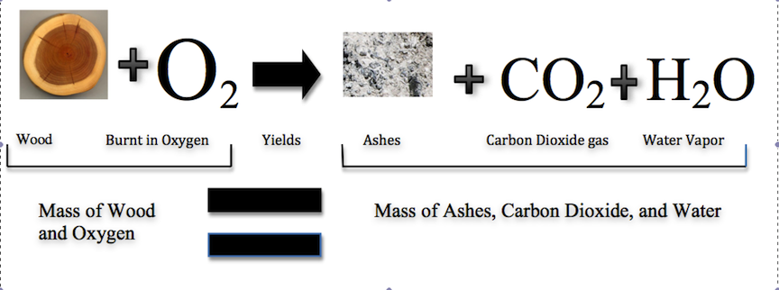  Decomposition/Rotting:  - Decomposition occurs when compounds _______ ______ (or decompose) into simpler compounds.  - Tiny living things called micro-organisms feed on the food and turn it into other substances, including nitrogen compounds and carbon dioxide gas.  - Still, no mass is destroyed even though it appears that it has. The mass is ________________.
Where did that new mass come from? | - Sometimes in chemical reaction, it seems like mass has been created. It HAS NOT!  - This is often because _____________________________ has been combined to form a new substance  - The mass of the reactants has not increased  - The mass of the products will still be exactly equal to the mass of the ________________!  Oxidation is defined as the interaction between oxygen molecules and all the different substances they may contact, from metal to living tissue  Examples:  Rust:  - Rust results when the _________ in air reacts with _____)  - Water can speed up this reaction (this means it acts a catalyst)  - As rust forms when iron (Fe) comes in contact with oxygen (O), it increases the _____ of the substance on which it forms because mass from the oxygen has now ___________ with the iron on the substance
So What?!
“I Own This” (Independent Practice)
- What is the chemical reaction for rust?

- Why does the formation of rust result in an increase in mass?

- What type of chemical reaction is occurring when fireworks are formed? How do you know?
- Where does the mass of the fireworks (reactants) go?

- When fluorine gas is put into contact with calcium metal at high temperatures, calcium fluoride powder is created. Why does calcium fluoride have a greater mass than the calcium metal did before the chemical reaction?

- What type of change occurred when the Statue of Liberty turned green? How do you know?

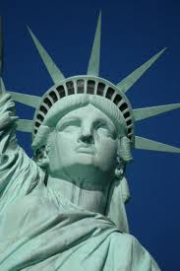
- When the Statue of Liberty was received from France, it has a mass of 204 116.4 kilograms. The Statue of Liberty now has a mass of 204,116.567 kg. Was this matter created?

- Where did this additional mass come from?

- A friend tells you that a campfire can destroy mass. Explain to them why they are wrong.

Ms. Riordan adds of a copper metal with a mass of 2 grams to a solution of nitric acid with a mass of 5 grams. When a strip of copper metal is placed into nitric acid a new substance is formed, gaseous nitrogen dioxide. The remaining mass of the metal and acid have a total mass of 6 grams.
- What is the total mass of the reactants?
- Ms. Riordan claims that mass has been destroyed. Is she right or wrong?
- Why?
- What will the total mass of the products be?

