Name: ____________________________ Homeroom:___________ Date: ________ 4.3
Products and Reactants (SPI.9.10)

Key Point | Notes
Chemical Reactions | A chemical change is a process involving one or more substances changing into NEW SUBSTANCES; this is also called a ______________ ____________.
Reactants | - Reactants are what you start or _______ with in a chemical reaction.  - These are the substances that ________ into a chemical reaction.
Products | - A substance which _______ as a __________ of a chemical reaction  - Products are what you _____ with in a chemical reaction
Chemical Equations | We use _________ _________ to show what happens in chemical reactions.  Ex: C₃H₈ + 5 O₂ 3 CO₂ + 4 H₂0  A chemical equation identifies the ___________ chemicals as REACTANTS and the finishing chemicals as _________________.  __________________ _____________________  “Reactants on the left, products on the right. I can talk chem equations all night, and you can make whatever you like, yeah, you can make whatever you like”  C₃H₈ + 5 O₂ 3 CO₂ + 4 H₂0  When you see “_______” or “produces” or “forms,” use an arrow ()  When you see “reacts with” or “and,” use a plus sign (+)
Phase Notations | There are 4 phase notations which are used to show which phase of ______ the reactant or product is in:  - Solid (__)  - _________ (l)  - Gas (_)  - In water/__________ (aq)
Ways to Write Chemical Equations | The two ways to write chemical equations:  - ______ Equations  - Skeleton Equations  Word equations:  Use _______ to show chemical reactions.  Ex: Solid iron and chlorine gas react to form solid iron(III) chloride  Skeleton equations:  Use ____________________________________________________ rather than words to identify products and reactants  Ex: 2H + O H₂O
So What?!
“I Own This”
1. In plants, a process called photosynthesis occurs whereby water (H₂O) and carbon dioxide (CO₂) get enough energy to make glucose (C₆H₁₂O₆) and oxygen gas (O₂). Write out the chemical equation for this reaction and label each term as a reactant or product

- Come up with your own real life analogies or examples for chemical reactions and include terms like reactant, product, and activation energy. Good analogies can be found in cooking. One example (that you may not use) is making a cake. You start out with the reactants: sugar, egg, flour, vanilla, baking soda, etc. add enough heat, which will supply the energy to allow the reaction to occur, and you end up with cake as the product.

3. For each of the following, circle the reactants and underline the products.

magnesium + vinegar magnesium acetate + hydrogen gas

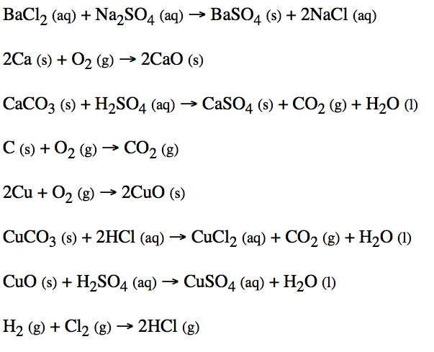
Hyrogen gas reacts with oxygen gas to produce water

Salt is produced from a combination of solid sodium and gasesous chlorine

