Name: _____________________________Homeroom: __________ Date: ________ 4.1
Introduction to Physical and Chemical Changes Homework (SPI.9.8)
Part I: Defining Physical and Chemical Changes
1. Fill in the table below with the appropriate missing information to describe physical and chemical changes.
 | Physical Changes | Chemical Changes
New substance formed?
Is composition or identity altered?
Are the reversible?
Do their products have new properties?
Are chemical bonds created?
Do their particles change?

Evidence of Change

2. Fill in the following Venn diagram with similarities and differences between physical and chemical changes:
Physical Change
Chemical Change

Part II: Common Outcomes of Chemical Changes
- List the common outcomes of all chemical changes. (Use your notes if you need help!)
1.
2.
3.
4.
2. A campfire is a chemical change. List three pieces of evidence from the campfire (thinking about the common outcomes of chemical changes and clues that chemical changes have occurred to explain why a campfire is a chemical change.
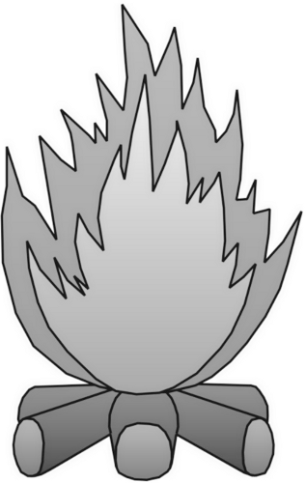

Part III: Classify Physical or Chemical Changes
Identify the following reactions by writing a C if the change is chemical and a P if it is physical.
1. ____ A bowl of cereal and milk
2. ____ Ripping a piece of money
3. ____ Roasting a marshmallow
4. ____ Fireworks
5. ____ Using hot glue
6. ____ Mixing baking soda and vinegar
7. ____ Lighting a match
8. ____ Crushing aluminum cans
9. ____ Shredding paper
10.____ An iron nail rusts
11. ____ Molding clay
12. ____ Cutting an egg
13. ____ A rotting ham
14. ____ Grinding rocks into sand
15. ____ Stirring lemonade
16. ____ Ice melts
17. ____ Burning a candle
18. ____ You heat a pot of water for cooking
19. ____ A new product is formed when two substances combine
20.____ Salt and pepper are mixed
21. ____ Tearing a office referral form
22. ____ Burning a piece of paper
23. ____ Milk goes sour
24. ____ Chopping wood
25. ____ Digesting your food

