Name: ____________________________Homeroom: ________ Date:__________ 3.9
Valence Electrons and Lewis Dot Structures (SPI.9.9)

Key Point | Notes
Valence Electrons | - _________ electrons are electrons in the ____________ energy level  - They are the furthest from the nucleus  - The maximum number of valence electrons are element can have is __  - The number of valence electrons of an element corresponds to its ________ number.  - Group 1 has ___ valence electron  - Group 2 has ___ valence electrons  - Groups 3-12 number of valence electrons varies  - Group 13 has ___ valence electrons  - Group 14 has ___ valence electrons  - Group 15 has ___ valence electrons  - Group 16 has ___ valence electrons  - Group 17 has ___ valence electrons  - Group 18 has ___ valence electrons  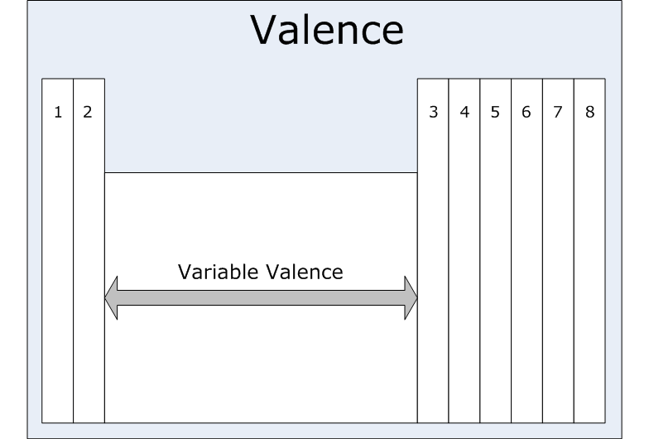  - Valence electrons predict how an element will chemically _________ with other elements.  - Elements within the ______ group of the periodic table share similar chemical characteristics and react with other elements similarly as a result of possessing the ______ number of valence electrons.
Lewis Dot Structures | Lewis Dot structures only show the number of valence electrons in an atom  - Valence electrons are the only electrons involved in __________  - Valence electrons are the most important electrons  - In Lewis Dot Structures, the “_____” represent valence electrons (e⁻)  Steps to Drawing Lewis Dot Structures:  - Write the __________ _________ of the element  - Determine ___________ of valence electrons  - Place single _____ on right side and add dots one at a time counter-clockwise.  Guided Examples:
So What?!
“We Own This” (Guided Practice):
Use M&M’s to show the Lewis Dot Structure for the following:

Cl
Rb
S
I

“I Own This” (Independent Practice):
1. Calculate the number of valence electrons in the following elements:
- Boron (B)
- Frankium (Fr)
- Tin (Sn)
- Radium (Ra)
2. Draw the Lewis Dot Structures for the following elements:
1. Boron 2. Arsenic 3. Argon
As
Ar
B

3. Fill in the missing information for the following elements (atomic #, element name, atomic mass, # of protons, # of neutrons, # of electrons, Bohr model, and Lewis Dot structure).
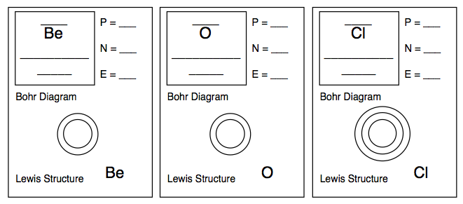
“Own This Even Further” (Early Finisher): Work on your “Hard Work” RAFT.

