Name: _____________________________Homeroom: ________ Date:__________3.8
Trends in the Periodic Table (SPI.9.9)

Key Point | Notes
Identifying Trends | Based on the information from my catalyst questions, I predict the following trends in the periodic table:  - The atomic number of elements in the periodic table (increases/decreases) as you move from right to left across a period and (increases/decreases) as you move from top to bottom down a group.  - The atomic mass of elements in the periodic table (increases/decreases) as you move from right to left across a period and (increases/decreases) as you move from top to bottom down a group.
Trend in Atomic Number (# of protons, # of electrons) | - The periodic table is organized in order of increasing atomic __________! Therefore, atomic number will _________ as you move from left to right across a period and as you move from top to bottom down a group.  - We also know that the atomic number is exactly ________ to the number of protons so the trend for protons will be the same  - In a neutral atom, the number of protons equals the number of ________, so the trend for electrons will be the same as well  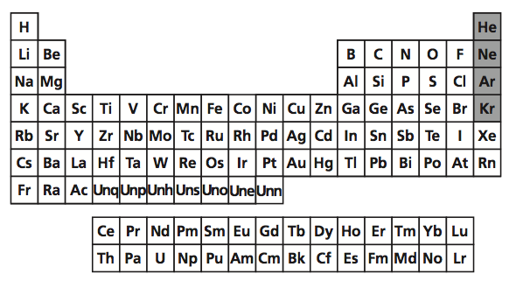
Trend in Atomic Mass | - Atomic mass is equal to the number of protons _____ the number of neutrons in the atom of an element  - We can think of atomic mass of how heavy a substance is  - Since the number of protons is increasing across and down the periodic table, the atomic mass is generally going to __________ as well  - Therefore, elements get ____________ as you move from left to right across a period and as you move from top to bottom down a group
Trend in # of Neutrons | - # of neutrons = ____________________________  - As a result of the atomic mass and atomic number increases, the number of neutrons will generally increase as well as you move across a period from left to right and as you move down a group
“I Own This”
Work on your “Hard Work” Study Guide RAFT. You should complete the following:
☐ Draw the trends we went over in class (show how these increase/decrease from right to left across a period and increase/decrease from top to bottom down a group):
☐Atomic number
☐# of protons
☐# of electrons
☐Atomic mass number
☐# of neutrons
☐ Write a minimum of one complete sentence including an explanation explaining each of the trends. (Ex: The number of protons increases in the elements of the periodic table as you move from left to right across a period and top to bottom as you move down a group because the atomic number increases and the atomic number represent the number of protons in the atom of an element.
☐Atomic number
☐# of protons
☐# of electrons
☐Atomic mass number
☐# of neutrons

