Name: ______________________________Homeroom: _________ Date: __________
Periodic Table Study Guide (SPI.9.9)
Part I: Periodic Table Basics (Groups, Periods, Atomic Number)
- The periodic table is arranged in order of increasing __________ ____________.
- What is an element’s atomic number equal to?
- Why are elements put together in the same group or family?

- What is a horizontal row on the periodic table called?

5. For the following elements, fill in the chart with their atomic number, group number, and period number.
Element | Atomic Number | Group # | Period #
Calcium (Ca)
Silicon (Si)
Chromium (Cr)
Bromine (Br)

Part II: Comparing # of Protons, Neutrons, and Electrons of Elements
- How do you calculate the number of neutrons in an element?

2. Why is the number of electrons equal to the number of protons in a stable atom?

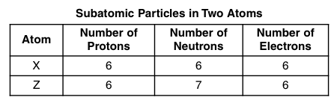
Using the table to the left, answer questions 3-4.
3. What is the atomic number of atom X?

4. What is the atomic mass of atom Z?
5. Fill in the table below with the appropriate missing information:
Element | Atomic Number | # of protons | # of electrons | # of neutrons
 | 29
Boron
 |  | 13
 |  |  | 9

Part III: Metals, Non-Metals, and Metalloids
1. Classify each of the following as a metal or nonmetal:

a) aluminum (Al)
b) iron (Fe)
c) oxygen (O)
d) carbon (C)
e) mercury (Hg)

2. Fill in the table with characteristics to describe metals and non-metals.
 | METALS | NON-METALS
Good conductors of heat and electricity? | No
Malleable?
Ductile?
Brittle? |  | Yes
Can they be a gas at room temperature?
Location in periodic table | Left

3. What kinds of properties do metalloids have?

4. Fill in the table below with the appropriate missing information:
Element | Chemical Symbol | # of protons | Metal, Non-metal, or metalloid? | # of neutrons
Hydrogen | H
Carbon
Nitrogen
Iron | Fe
 | Cu
 | Ge

5. Aluminum (Al) is used to make aluminum foil. What property of aluminum allows the aluminum foil to change its shape?

6. If the price of aluminum (Al) increased dramatically, or there was a worldwide shortage of aluminum, would it be possible to substitute magnesium (Mg) in the household objects like aluminum foil? Use evidence from the periodic table to help support your answer.

Part IV: Trends in the Periodic Table
- The atomic number of elements in the periodic table (increases/decreases) as you move from right to left across a period and (increases/decreases) as you move from top to bottom down a group.

- The atomic mass of elements in the periodic table (increases/decreases) as you move from right to left across a period and (increases/decreases) as you move from top to bottom down a group.

- Place the following elements in order of decreasing atomic number.
Mg, Sr, Ca
4. Place the following elements in order of increasing atomic mass.
O, B, C

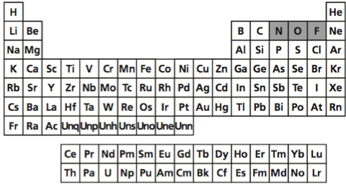
For questions 6-9 below, circle the letter of the correct answer in the following multiple-choice questions. Only use the periodic table above!

6. Which of the following correctly places elements in order of decreasing atomic mass?
a. He, O, F, C
b. Xe, Ar, Ne, He
c. Li, H, Na, K
d. Co, Ni, Cu, Zn

7. Which of the following correctly places elements in order of increasing atomic number?
a. He, Li, C, N
b. O, N, C, B
c. F, I, Br, Cl
d. Al, Si, As, B

8. Which of the following elements has the most electrons?
a. Mg
b. Ca
c. Be
d. Sr

9. Which of the following elements has the most protons?
a. H
b. N
c. Br
d. He
GOOD LUCK! STUDY TONIGHT! USE YOUR STUDY GUIDE TO YOUR ADVANTAGE!

