Name: ______________________________ Homeroom: _________ Date: _______ 3.7
Groups on the Periodic Table (SPI.9.9)

Key Point | Notes
Metals vs.  Non-Metals vs. Metalloids | Metals are found on the __________________ side of the table, while the nonmetals are found on the ___________________ side of the table.  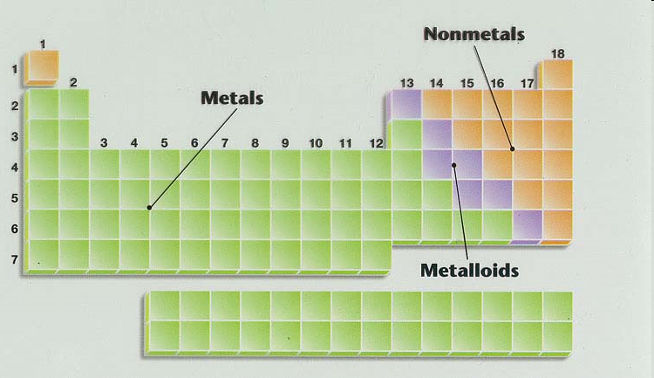  Metals Non-metals  Are good _____________ of electricity and heat Are bad conductors of electricity and heat  Are shiny Not shiny  Are ____________ (can be beaten into thin sheets) Are __________ (break easily)  Are ductile (can be stretched into wire) ____________________  Metalloids are elements that have properties that are __ _____________ metals and nonmetals.
Alkali Metals | - Group ___ on the periodic table (but does not include ___________)  - React aggressively especially with halogens
Alkaline Earth Metals | - Group ____ elements in the periodic table  - Fairly reactive
Halogens | - Group _____ on the periodic table  - Highly ____________
Noble (Inert) Gases | - Group 18  - Inert means “________________”  - The ________ ____________ of all elements on the periodic table  - All __________ at room temperature
So What?!
“We Own This”
Work on your “Hard Work” Study Guide RAFT. You should complete the following:
☐ Name and title your study guide. You can be creative. (example: Mr. C’s Periodic Table)
☐ Fill in the atomic number for all of the elements

☐ Create a “key” example indicated when the atomic number, chemical symbol, and atomic mass is located in each box on the periodic table.

☐ Color-code the metals, non-metals, and metalloids

☐ Write the atomic mass for elements 1-20
☐ Number the periods on your periodic table
☐ Number the groups on your periodic table
☐ Name the specific groups we have talked about in class (Alkali metals, Alkaline Earth metals, halogens, and noble gases)
☐ Create a key to help you calculate “atomic math”
☐ How do you calculate the # of protons?
☐ How do you calculate the # of electrons?
☐ How do you calculate the # of neutrons?

“I Own This” (Independent Practice):
1. The elements characterized as nonmetals are located in the periodic table at the
(A) far left; (B) bottom; (C) center; (D) top right.

2. Elements that have properties of both metals and nonmetals are called
(A) metalloids; (B) halogens; (C) alkali metals; (D) transition elements.

3. Which is the atomic number of an alkali metal?
(A) 10; (B) 11; (C) 12; (D) 13.

4. Which element is a halogen?
(A) iron; (B) nitrogen; (C) iodine; (D) neon.

5. Metals are found on the __________________ side of the table, while the nonmetals are found on the ___________________ side of the table.

