Name: _____________________________Homeroom: _________ Date: _________ 3.5
Introduction to the Periodic Table Homework (SPI.9.9)
Part I: Reading the Periodic Table
- What is the Periodic Table?

- Label the parts and fill in the blanks (use atomic number, atomic mass, chemical symbol, element name, # of protons, # of neutrons, # of electrons)
3

Li
Lithium

6.94

- Write the chemical symbols or the element names for each of these elements:

  - Chlorine __________________
  - Copper ___________________
  - Potassium _________________
  - Silver ____________________
  - Na _____________________
  - Sn _______________________

- What is the atomic number of:

  - Calcium____
  - Iron _____
  - Gold_____
  - Uranium_____

- Fill in the following chart with the correct missing information.
Element Name | Chemical Symbol | Atomic Number | Atomic Mass
Nitrogen

 |  | 10
 | Br
 |  |  | 16.0

Part II: Atomic Math (Calculating the # of Protons, Neutrons, and Electrons)
- An element has 13 protons, which element is this?

- The number of protons in Potassium (K) is?

- The number of electrons in Potassium (K) is?

- What is the atomic mass number of Ca?
  - What is the total number of protons?
  - What is the total number of neutrons?
- What is the atomic mass number of Mn?
  - What is the total number of protons?
  - What is the total number of neutrons?
- What is the total number of neutrons in Silver (Ag)?
- Fill in the following chart with the correct missing information.
Element | Atomic Number | # of protons | # of electrons | # of neutrons
Fluorine (F)
 |  | 19
 |  |  | 6
 |  | 35
 |  |  |  | 19
 | 15

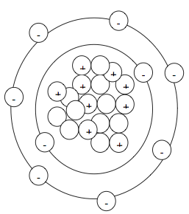
Use the Bohr model to the left to answer questions 8-12.
8. How many electrons does this atom have?
9. How many protons does this atom have?
10. How many neutrons does this atom have?
11. What is the atomic number?
12. Find the name of this element by referring to the periodic table.

13. Does mercury (Hg) have more protons and electrons than tin (Sn)?
14. Is mercury (Hg) a heavier element than tin (Sn)?
15. Does potassium (K) have more electrons than neon (Ne)?
16. Does hydrogen (H) have more electrons than fluorine (F)?
17. Which has more protons, sulfur (S) or iodine (I)?
18. Which has more protons, gold (Au) or silver (Ag)?

