Name: ____________________________ Homeroom: ________ Date: __________ 3.4
Density Study Guide #2 (SPI.9.7)
Part I: Sink or Float?
Using the density column on the left, answer questions 1-5.
- What substance is the most dense?
- How did you know?

- What substance is the least dense?
- How did you know?

- Why is the ping-pong ball floating on top of the lamp oil?
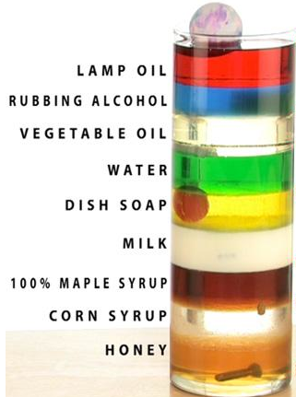
Answer questions 6-7 using your scientific knowledge of density.
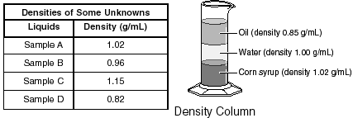
6. Students measured and recorded the density of 4 samples. Using the density column and the data table above, which of the samples will probably float on top of the oil?

7. A student adds a mixture of oil, sand, and salt to a beaker of water and stirs. The student stops stirring and observes that the salt is no longer visible, the oil floats to the top, and the sand sinks to the bottom of the beaker. Explain why the oil floats after the stirring stops.

Part II: Calculating Density
Using the equation and table below, calculate the density of each solid and identify it by name.
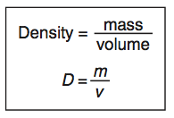
Solid | Density (g/cm³)
Cork | 0.25
Brick | 1.80
Glass | 2.24
Stainless steel | 7.90

1. A solid has a mass 18 grams of and a volume of 10 cm³
Density: Solid:

2. Gregory has 16 cm³ solid with a mass of 4 grams
Density: Solid:

3. Jeremy uses a ruler to measure the volume of a cube to be 4 cm³ and measures the same cube to have a mass of 31.6 g on a triple-beam balance
Density: Solid:
Calculate the densities of all of the samples in the table below:
WORK SPACE:
Sample | Mass (g) | Volume (cm³) | Density (g/cm³)
Aluminum bar | 5.4 | 2.0
Iron pipe | 160 | 20
Gold coin | 30 | 1.5
Wooden block | 4.0 | 5.0
Stone | 6.2 | 3.1
Aluminum block | 8.22 | 3.0

Part III: Solving for Volume Using the Density Equation
Use the equation below to solve for the volume in the following problems.
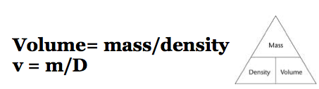
1. Calculate the volume for substances A-D.
Substance | Density (g/cm³) | Mass (g) | Volume (cm³)
A | 2.0 | 100
B | 0.8 | 240
C | 5.0 | 100
D | 3.5 | 3.5

2. What is the volume of a 22.6-gram block of lead? The density of lead is 11.3 g/cm³.

3. The density of cork is 0.24 g/cm³. What is the volume of a 240-gram piece of cork?

Part IV: Solving for Mass Using the Density Equation
Use the equation below to solve for the mass in the following problems.
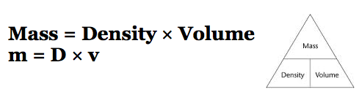
- What is the mass of an iron horseshoe with a volume of 89 cm³? The density of iron is 7.9 g/cm³.

- The density of mercury is 13.6 g/mL. What is the mass of a 10 cm³ sample of mercury?

