Name: ________________________________ Homeroom:________ Date: _______ 3.3
Density Homework (SPI.9.7)
Part I: Dividing Without Using a Calculator!
Solve the following math problems without using a calculator (using a calculator is considered cheating!!)

1. 88 ÷ 4 =
2. 202 ⁄ 2 =
3. 1/4=
4. 435 ÷ 5=
5. 875÷ 125 =
6. 6 ÷ 12=
7. 11/44=
8. 999/9=
9. 1 ÷ 2=
10. 60÷12=

Part II: Using Division to Solve for Density
Density is a measure of the amount of mass in a certain volume. This physical property is often used to identify and classify substances. It is usually expressed in grams per cubic centimeters, or g/cm³.
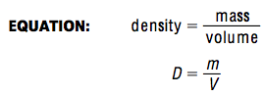
SAMPLE PROBLEM: What is the density of a billiard ball that has a volume of 100 cm³ and a mass of 250 g?
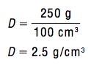
Using the example and equation above, solve for density in the following problems. You may not use a calculator. Be sure to include your units!
- A loaf of bread has a volume of 2270 cm³ and a mass of 454 g. What is the density of the bread?

- One liter of water has a mass of 1000 g. What is the density of water?

- Lateriona has a watch. It has a mass of 2 g and a volume of 4 cm³. What is the density of the watch?

- Miguel has a wallet. It has A volume of 5cm³ and a mass of 15g. What is the density of his wallet?

- JaSun found a rock with a mass of 6 grams and a volume of 12 cm³. What is the object’s density?

Using the mass and volume given below, solve for the density of the substances below. Then, use the data table below to name each substance. You can use the space to the right of the data table as work space to calculate density.
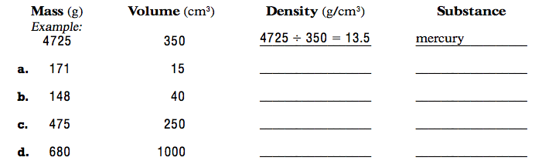
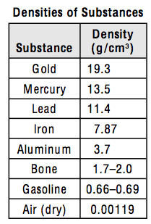
WORK SPACE:
Part III: Sink or Float?
The following liquids were spilled into the tank:
• a green liquid that has a volume of 48 L and a mass of 3 kg
• a blue liquid that has a volume of 144 L and a mass of 4 kg
• a red liquid that has a volume of 96 L and a mass of 3 kg
• a black liquid that has a volume of 120 L and a mass of 6 kg

- Calculate the density of each liquid.
Green liquid:
Blue liquid:
Red liquid:
Black liquid:
2. Determine the order in which the liquids have settled in the tank.
First (bottom):
Second:
Third:
Fourth (top):
BEAST QUESTION: A block of wood has a density of 0.6 g/cm3 and a volume of 1.2 cm³. What is the mass of the block of wood? Be careful!

