Name: _______________________________Homeroom: __________ Date:________
Particle Arrangement Study Guide (SPI.9.6)
Part I: States (Phases) of Matter
- Fill in the following table to describe solids, liquids, and gases.
Phase of Matter | Solid | Liquid | Gas
Does this phase of matter have a definite shape?
Does this phase of matter have definite volume?
Does this phase take the shape of its container?
Does this phase take the volume of its container?
How do these phase rank in order of relative speed?

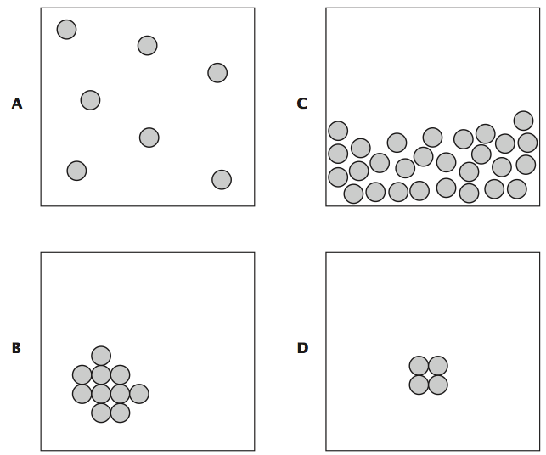
2. Using the diagrams to the left, classify A-D as solid, liquid, or gas.
A.
B.
C.
D.
Part II: Phase Changes
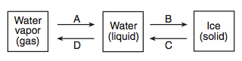
Using the diagram above, name the phase change that occurs at changes A-D. For each one of the phase changes, state if the speed of the particles increase or decreases and if the distance between the particles increases or decreases. The first one is done for you.

 | Phase change | Speed of the particles | Distance between the particles
A. | condensation | decreases | decreases
B.
C.
D.

Part III: Particle Arrangement and Particle Motion
- Solids have a definite shape and volume. Based on the arrangement of the particles in a solid, why do solids have a definite shape and volume?

- Liquids take the shape of their container. Why do they do this, based on the arrangement of the particles in a liquid?

- Gases are very compressible (we can change their volumes). Based on the arrangement of their particles, why are we able to compress gases?

4. Fill in the following table with the appropiate information:
 | Solid | Liquid | Gas
Arrangement | Very close
Motion |  |  | Moves quickly in all directions
Amount of Kinetic Energy |  |  | High
Properties |  | Fixed volume, no fixed shape
Diagram (Drawing) of particles
- When water vapor condensing into water droplets on grass in the morning time,
  - What happens to the distance between the particles?
  - What happens to the speed of the particles?
  - What happens to the kinetic energy of the particles?
- Create a bar graph comparing the different states of matter (independent variable) and the distance between their particles (dependent variable).

- Create a line graph showing the relationship between state of matter (independent variable) and the speed of the particles (dependent variable).

MAKE SURE YOU STUDY! YOU MATTER AND YOUR EDUCATION MATTERS!!

