Name: ____________________________ Homeroom: __________ Date:_________ 3.1
Phases of Matter (SPI.9.6)

Key Point | Notes
Matter | All matter is:  - Made of ___________  - Has mass  - Has ___________ (takes up space)  - In four _________ (phases)  The states of matter are four distinct ______ that matter can take. They consist of:  - Solid  - Liquid  - Gas  - Plasma
Solids | The properties of solids are:  - fixed shape that is rigid  - fixed volume  - Do not take the shape of their container  - very dense  - particles vibrate in place  Examples: Wood, Plastic, Metal
Liquids | The properties of liquids are:  - No fixed (_________) shape  This allows them to take the shape of their container  - Definite/fixed volume  - Particles ______. They can move around but are still close together.  Examples: Water, juice, milk
Gases | The properties of gases are:  - NO fixed ________; this allows them to take shape of container  - NO fixed volume; this allows them to take volume of container  - _____ dense  - Particles are very _____ apart  Examples: Air, Oxygen, Carbon Dioxide
Plasmas | The properties of plasmas are:  - __________ particle motion (particles are electrically charged)  - Particles collide with enough energy to break into _______ particles (+/-)  - _____-like, indefinite shape & volume  Examples: stars, fluorescent light bulbs, TV tubes
Phase Changes | A phase change occurs when a substance __________ from one state of matter to another  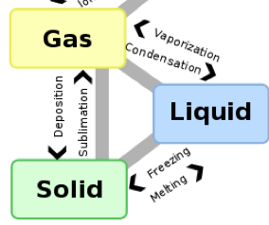  Melting: solid to _________  Freezing: liquid to solid  Condensation: gas to liquid  Evaporation: _________ to gas  Sublimation: solid to gas  Deposition: gas to solid
Adding and Removing Heat | 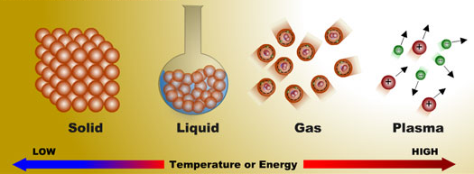
Heating Curves
So What?!
“I Own This” (Independent Practice):
- How do liquid water, ice, and water vapor differ from each other?
  - They are different phases of matter.
  - They are different compounds.
  - They are made of different kinds of molecules.
  - They are made of different kinds of atoms.

- A solid is a state of matter that has a(n)
  - indefinite volume and an indefinite shape.
  - definite volume and a definite shape.
  - definite volume and an indefinite shape.
  - indefinite volume and a definite shape.

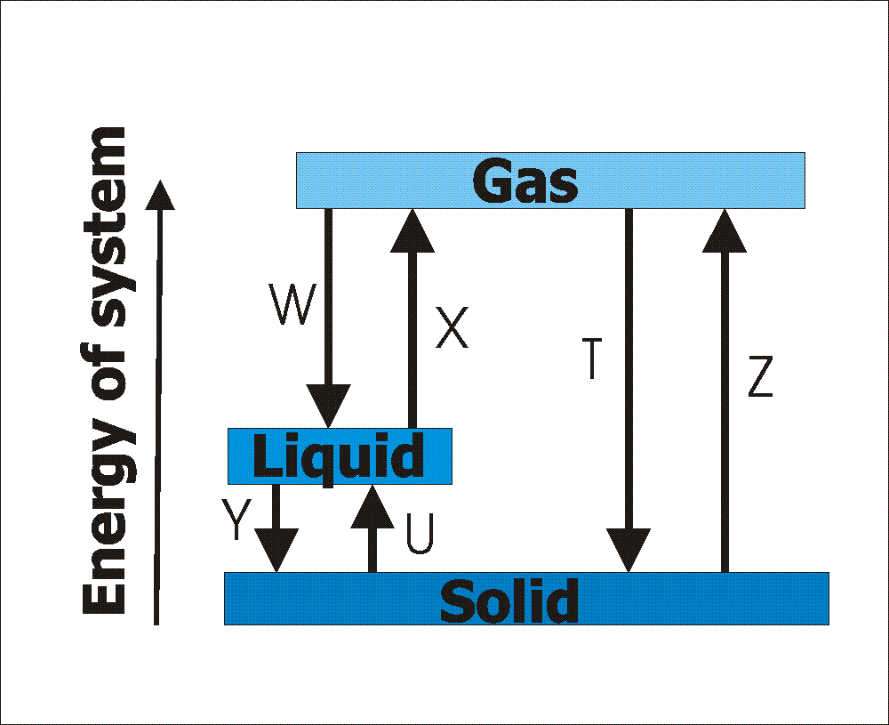
Using the diagram to the left, label the phase changes that are occurring for each letter:
T:
U:
W:
X:
Y:
Z:

