Name: ____________________________ Homeroom: _________ Date: ________ 3.11
Acids and Bases (SPI.9.12)

Key Point | Notes
Acids | Acids:  - Taste _______  - pH _____ than 7  - Corrode metals  - Produce ____ (as H₃O⁺/hydronium) ions in water (the hydronium ion is a hydrogen ion attached to a water molecule)  - React with metals to give off hydrogen gas  - Conduct ____  - Turn litmus paper RED  Examples of acids:
Bases | Bases:  - Soapy/_________ feel  - Bitter, chalky taste  - Produce ____ (hydroxide) ions in water  - pH ________ than 7  - Conduct Electricity  - Turn Litmus Paper BLUE “Basic Blue”  Examples of bases:
pH scale | The pH scale is used to express the strength of acids and bases solutions. It ranges from _________  - Acids have a pH _____ than 7  - Bases have a pH more than ____  - Neutral solutions have a pH of _________ 7
pH | pH is a measure of how many hydronium (H₃0⁺) and hydroxide (OH⁻) ____ are in a solution  - Remember, an _______ produces hydronium (_____) ions when it dissolves in water  - A base produces hydroxide ions (_____) when dissolved in water
Weak vs. Strong Acids/Bases | - The stronger a ______ is, the __________ the pH  - The stronger an ______ is, the __________ the pH  - As we move closer to 7 from either direction, acids and bases become weaker and more neutral  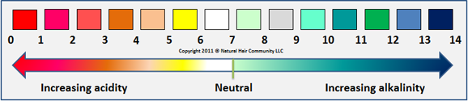
So What?!

“We Own This” (Guided Practice):
Fill in the following Venn diagram with the characteristics that we decide upon as a class below:
BASES
ACIDS

“I Own This” (Independent Practice):
1. Fill in the following table to differentiate between acids and bases:
 | Acids | Bases
pH |  | Greater than seven
Taste
Feel | Varies
Produce what ions?
Produce electricity?
What color do they turn litmus paper?
Examples

2. Is an acid with a pH of 6 strong or weak? Why?

3. Is a base with a pH of 13 strong or weak? Why?

