Name: _____________________________ Homeroom:_________ Date: ________ 3.10
Reactivity and Bonding (SPI.9.9)

Key Point | Notes
Chemical Bonds | - Chemical bonds are the forces of attraction that hold atoms together  - When atoms interact to form a bond, only their outer ___________ come in contact  - Bonds are formed by transferring electrons (losing or gaining them) (IONIC BONDS) or by sharing electrons (COVALENT BONDS)
The Octet Rule | - The octet rule states that atoms of elements tend to gain or lose _________ in order to possess _______ valence electrons (or a stable full energy level).  - If an atom has 3 or less valence electrons, it will ______ these electrons.  - If an atom has 4 or more valence electrons, it is going to _______ electrons until it has a full energy level.  - Elements that are _________ to fulfilling their octet (becoming stable with 8 valence electrons) are the most __________with other elements  EIGHT IS GREAT!!!
Reactivity of Specific Groups | - Alkali metals (group 1): are _______ reactive  - Alkaline earth metals (group 2): very reactive  - Halogens (group 17): highly reactive, likely to react with a alkali metals  - Noble/Inert gases (group 18): ______ react with ANYONE! They are the least reactive because they __________ have eight valence electrons. They are noble, inert!
Trend in Reactivity | - Elements that are more _________ are more likely to form compounds (through the creation of chemical ______ with other atoms)  - This means that they will more readily chemically combined with another element to form a completely new substance  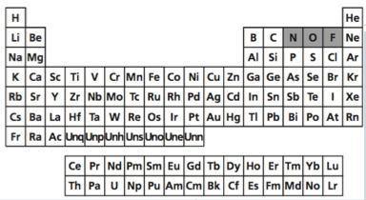
So What?!
“I Own This” (Independent Practice):
- What element is the most reactive element on the periodic table? How do you know?

- Which group is the least reactive? Why?

- Which groups are the most reactive? Why?

Place the following elements in order of increasing reactivity.
4. B, Be, F
5. Cl, S, P, Ar
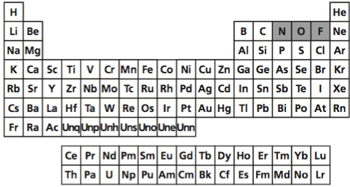
Circle the letter of the correct answer in the following multiple-choice questions (questions #6-7). Only use the periodic table above!
6. Which of the following is the most reactive?

a. Helium (He)
b. Argon (Ar)
c. Radon (Rn)
d. Hydrogen (H)

7. Which of the following would most likely form a compound with hydrogen?

a. Chlorine (Cl)
b. Calcium (Ca)
c. Neon (Ne)
d. Lithium (Li)

8. Use the remainder of your class time to work on your “Hard Work” RAFT!
☐ Create a key to help you determine an element’s reactivity and number of valence electrons
☐ How do you calculate the number of valence electrons?
☐ How do you draw a Lewis dot structure?
☐ Give an example element of a Lewis dot structure
☐ Write a minimum of one paragraph explaining reactivity. (Include a detailed explanation of the Octet Rule)
☐ Explain the theory of the Octet Rule or “eight is great”
☐ What elements are highly reactive? Why?
☐ Discuss how reactivity plays a role in bonding

“Own This Even Further” (Early Finisher):
Work on your “Hard Work” RAFT!!

