Name: ___________________________Homeroom: ___________ Date:________ 2.7
The Chemical Make-Up of Our Atmosphere (SPI.9.5)

Key Point | Notes
What Gases Make Up Our Atmosphere? | - Our atmosphere is a _____________ of gases!  - Earth’s atmosphere is made up of the following gases:  - ____% nitrogen (N₂)  - 21% __________ (O₂)  - 1% other gases including: carbon dioxide (CO₂), argon (Ar), water vapor (H₂O), neon (Ne), helium (He), methane (CH₄), hydrogen (H₂), krypton (Kr), and ozone (O₃)  - Oxygen and nitrogen exist as ____________ molecules in our air  - “Di” = _____  - 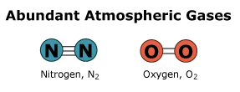  - Would nitrogen and oxygen be better described as an element or compound?  - Why?  - What word could you use to even better describe them?
Pie Chart of the Gases in Our Atmosphere | Draw your own pie chart of the gases in Earth’s atmosphere:  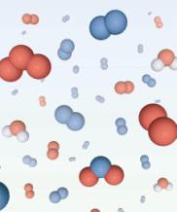
Drawing a Model of the Mixture of Gases in Our Atmosphere | Draw your own model of the atoms of the gases in  our atmosphere:
Benefits of the Chemical Make-Up of Earth’s Atmosphere | - Our atmosphere has ___________, which ensures our survival  - With too much oxygen, oxygen will chemical bond with other substances forming rust  - With not enough oxygen, we would not be able to __________!  - ______________ gases (like CO₂ and CH₄) trap heat  - Without the presence of these greenhouse gases, life on Earth would be too cold to exist  - With adding more greenhouse gases to our atmosphere (like CO₂) we are beginning to trap more heat resulting in ________ _______________! We do not want to do this!
So What?! | Write a summary of what you learned today here and why learning about the gases in our atmosphere is important to you in the real-world:
“I Own This” (Independent Practice):
- What gas is the most abundant (common) in our atmosphere?

- Fill in the table below with the appropriate percentages for the following gases
Gas | Chemical Symbol/Chemical Formula | Element or Compound? | % of Earth’s Atmosphere
Oxygen | O₂
Argon | Ar
Nitrogen | N₂
Helium | He
Carbon Dioxide | CO₂
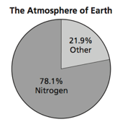
- Using the picture to the right, what makes up the “other” is this circle graph?

- Draw the atomic arrangement of the gases in our atmosphere.

- Using the table below, describe some key differences between our atmosphere and the atmosphere of Mars and Venus.
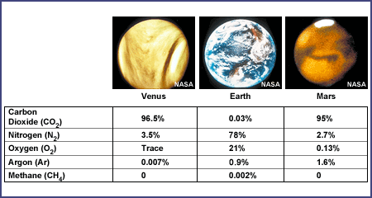
- What difference do you think these differences in atmosphere make?

