Name: __________________________ Homeroom:___________ Date: _________ 2.6
Separating and Drawing Mixtures (SPI.9.4)

Key Point | Notes
Separating Mixtures by Physical Means | - Mixtures are PHYSICALLY combined, so they can be ______________ separated.  - Chemists separate mixtures by using differences in physical _____________ of each part.  Separation by density:  - Based off differences in density, you can separate ___________ from each other  - Example: Oil and water  Separation by magnetism:  - Based on differences is magnetism, you can separate magnetic objects from _____________ objects  - Ex: Rocks and Coins  Separation by filtration:  - Filtration separates a ________ from a liquid by filtering out the liquid.  - Ex. sand and water mixture, spaghetti and water  Separation by heating:  - Based on differences in boiling points, you can separate dissolved solids from liquids  - Ex: Boil salt water to allow the water to evaporate and you are left with salt  - The lab tool that is used to heat a substance is a ____ __________  Identify the technique you would use to separate the following mixtures:  - Remove rocks from an ocean water sample.  - A solution of salt water.  - A mixture of oil and water.  - Isolate sugar from a sugar-water solution.  - A mixture of paperclips and rice
Drawing Elements | - The particles shown here are all the same.  - Each particle is an atom and all the atoms are of the _______ kind.  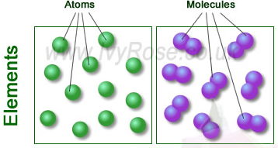
Drawing Compounds | - Two or more ____________ atoms are shown (because compounds are made of two or more different elements)  - The atoms are connected to show that there is a chemical ____ between them  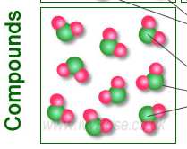
Drawing Mixtures | - Mixtures made up of _____ than one substance  - The substances are physically combined so the atoms are ___ connected  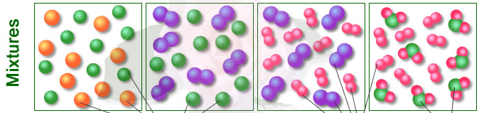
Drawing  Molecular Models | - An element  2. A different element  3. A mixture of these two elements  4. A compound of these same two elements
So What?! | Write a summary of what you learned today here and why it matters to you:
“We Own This” (Guided Practice):
Write down notes from today’s Jury Duty.

