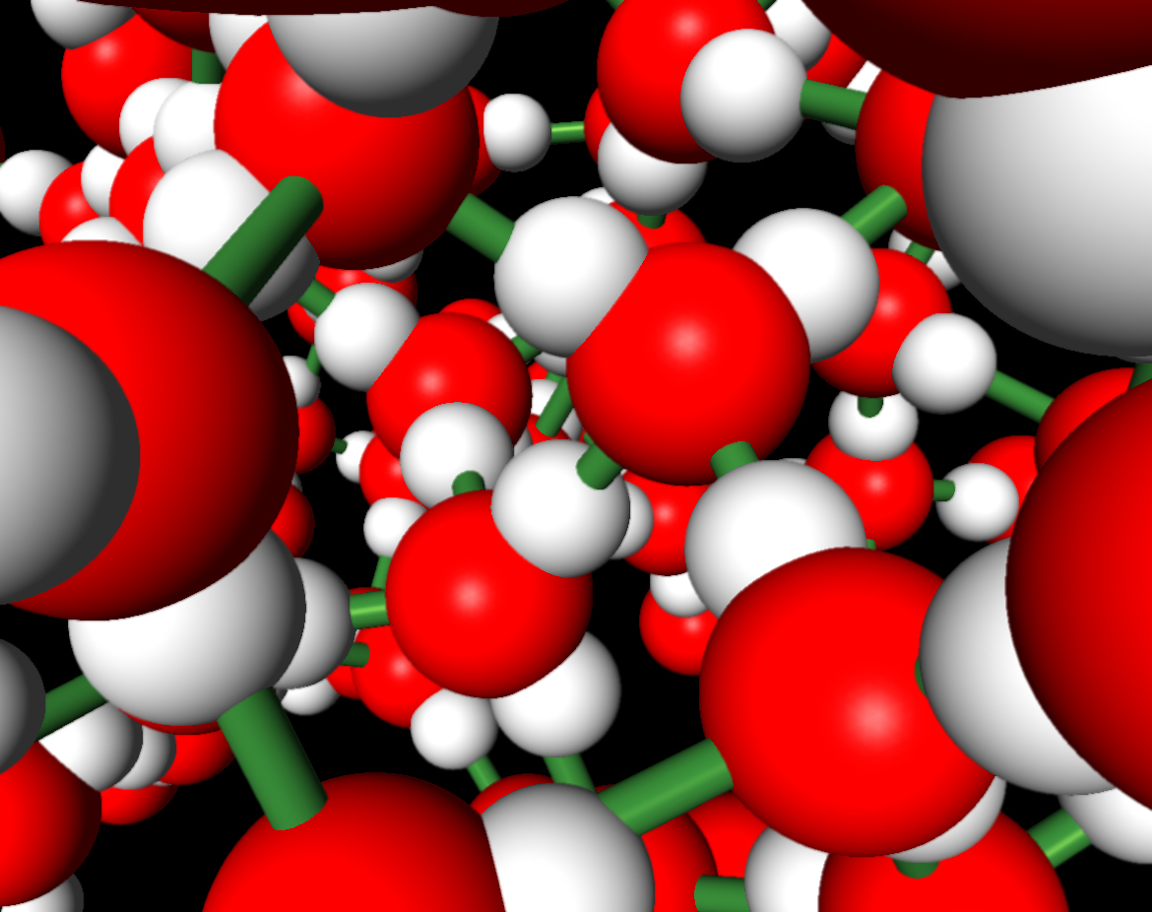
Name: _____________________________Homeroom: __________
Elements Vs. Compounds Study Guide (SPI.9.3)
Part I: Elements
- What is the definition of an element?

- What is used to abbreviate an element?

- Where is a list of all of the elements in order of their atomic number found?

- What subatomic particle determines which element an atom forms?

Use the portion of the Periodic Table below to answer questions 5-12.
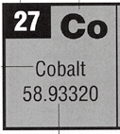
- What is the chemical symbol for the element cobalt?
- What is the atomic number for cobalt?
- How many protons would be in the nucleus of Cobalt?
- How many electrons would be orbiting cobalt’s nucleus?
- How many different types of atoms would be an element of cobalt?
- Can cobalt be separated further by physical or chemical means?
- Why or why not?

- BEAST: How many neutrons would be in the nucleus of an atom of cobalt?

Part II: Drawing a Bohr Model of an Atom.
- Draw a Bohr model for the element Be. (Be has 5 neutrons)

- Draw a Bohr model for carbon. (Carbon has 6 neutrons)

Part III: Compounds
- How are compounds combined?
- What is used to abbreviate a compound?
- What is the difference between a molecule and a compound?

- Can compounds be made of only the same element?
- Describe the properties of compounds compared to the elements that combine to make them up.
Use the diagram of glucose (C₆H₁₂O₆) below to answer questions 6-8.
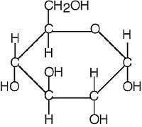
6. Is glucose an element or compound?
7. How many different elements is glucose made up of?
8. How many atoms of carbon are in glucose?
Part III: Distinguishing Between Elements and Compounds
For all of the following formulas, indicate if they best represent an element, molecule, or compound. Note: all compounds are best described as compounds.
- F
- NH₃
- N₂O
- C₂
- C₃
- HCN
- C₂H₆
- NO
- Fe₂O₃
- CaCO₃

Describe the following diagrams as elements, molecules, or compounds.
2.
1.
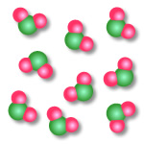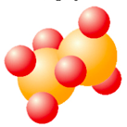

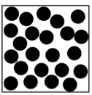
4.
3.
HARD WORK IS THE ELEMENT TO SUCCESS!! STUDY HARD!

