Name: __________________________Homeroom: ____________ Date: ________ 2.1
Defining and Measuring Matter (SPI.9.1)

Key Point | Notes
Matter | Matter is:  - Anything that has __________ and takes up space (has ______________)  - Made up of different kinds of ___________  - Does not include heat, sound, or light
Mass | Mass is how much matter is in something.  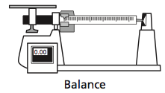
Measuring Mass | - Mass is measured using:  A triple-beam balance  - The units of measurement for mass:  Grams or ________________
Volume | Volume is how much ___________ something takes up.
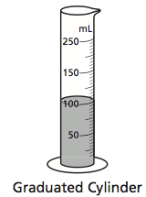  Measuring Volume | - You can measure the volume of regularly shaped solids (like a cube) using a __________.  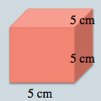  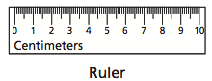  Guided Example:  - Here volume = length × width × height  - Volume = 5 cm × 5 cm × 5 cm = 125 cm³  - The volume of liquids can be measured using:  - Graduated cylinder  - When measuring the volume of irregularly shaped solid objects, you can use a graduated cylinder filled with ______________:  Steps to solving:  - Measure the ___________ (starting, beginning) volume of the water.  - Drop the object in the graduated cylinder.  - Measure the new (________, ending) volume of the water.  - Find the ______________ between the new volume and old volume.  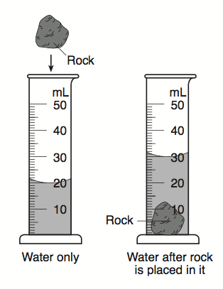  Guided Example:  - The units for volume are:  - Cubic centimeters (_____) or cubic meters (m³)  - Milliliters (____) or liters (L)
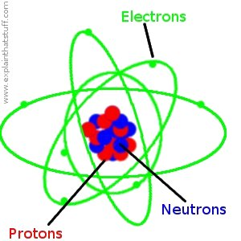  Atom | - Matter is made up of tiny particles called __________.  - ****ALL MATTER IS MADE OF ATOMS!!!!****  The atom:  - is the _____________ _________ of matter.  - Without it, we would not exist!  - the smallest particle of an element that can be divided and still have the same ______________ of that element!  - the smallest unit of matter (makes up everything that is matter!)
So What?! | Write a summary of what you learned today here:

“I Own This” (Independent Practice):
- What are the characteristics of all matter?

- Calculate the volume of the rectangular block.
Volume = Length x Width x Height
2 ft
Volume of the rectangular block =

5 ft
2 ft

- Calculate the volume of the rock in the graduated cylinder
to the right.

- Explain why a speck of dust would be considered matter.

- What is the building block of all matter?

- Define the word atom in three different ways.

