Name:_____________________________Homeroom: _________ Date:________ 1.6

Graphs: Scatterplots and Correlation of Data (SPI.MATH.5.3)

Key Points | Notes
Six Stellar Steps for Creating a Line Graph | - Draw the __________  - x-axis independent variable  - y-axis dependent variable  - Label the axes with correct _________  - _________ the graph (includes (IV and DV)  - Plot your points from your data table
Scatterplot | - Scatter plots are used to examine two sets of data and to investigate the possible relationship (or _______________) between two variables. The pattern of the points suggests how ______________ the data is related.
Scatterplot Vs. Line Graph | - Both start with mapping _____________ (numerical) data points  - _____________ also allow you to see outliers  - In a scatterplot, the individual points should not be connected directly together with a line.  - In a line graph, each data point is ______________ together. In this way, the local change from point to point can be seen.
Correlation | - Scatter plots show how much one variable is _______________ by another. The ________________ between two variables is called their correlation.  - If the data points in a scatter plot lie ________ to a line, the scatter plot shows a strong correlation.  - If the data points in a scatter plot do not lie close to a line, the scatter plot shows a ________ correlation.
Positive Correlation | - A positive correlation be seen in a scatterplot of the overall trend is increasing  - If the data displayed on the scatter plot forms a line that _________ from left to right, the variables are said to have a positive correlation.  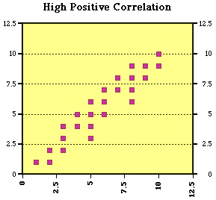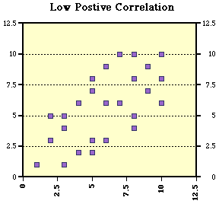
Negative Correlation | - A negative correlation be seen in a scatterplot of the overall trend is ________________.  - If the data displayed forms a trend line that FALLS from left to right, the variables have a negative correlation.  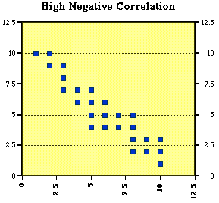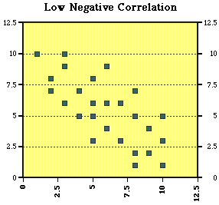
No Correlation | 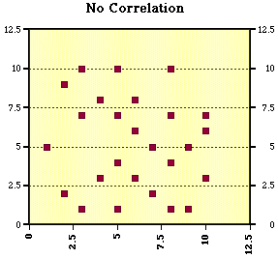
Line of Best Fit | - A line of best fit is a straight line that best represents the data on a scatter plot.  - This line may pass through some of the points, ________ of the points, or all of the points.  - These lines of best fit help you predict future data points  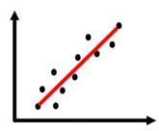

Additional Notes and Examples from Class:

