Name: ___________________________ Class: _____________ Date:________ 1.3
Homework: Conclusions and Human Error
Directions: Answer the following questions.

1) What are some types of errors humans make while conducting experiments?

2) The three main sources of biases are incomplete information, past experiences influencing the present, and ________________________________________________________.

3) Kayla wants to figure out which of three types of batteries (battery A, B, or C) lasts the longest. Kayla used three different types of flashlight and put one type of battery in each flashlight. Then she turned them on at different times and timed how long each flashlight remained lit. Use Kayla’s experiment to answer these questions.
A) What question is Kayla trying to answer by doing this experiment?

B) What is one thing Kayla has to change about her experiment (do differently) to make it better and fairer? In other words, what variables she have to CONTROL?

C)) Let’s say Kayla found that the flashlight with battery A turned off first. The flashlight with battery B died second. The flashlight with battery C stayed on the longest. What CONCLUSION can Laura make about which battery lasts the longest?

4) Some students investigated plant growth by growing two sets of the same type of plant. One set was grown indoors and the other set was grown outdoors. They recorded data in the table below.
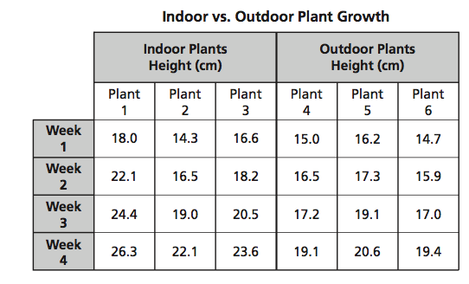
The students concluded that the plants grown indoors grew faster because they received better quality light than the plants grown outdoors. Which is the most likely reason this conclusion may be flawed?

5) Mr. Boggs wants to create an experiment to see how much his scholars grow on the TCAP writing prompt. He looks at their TCAP scores in February. He concludes which scholars grew the most in their writing skills by seeing which scholars scored the highest on the February TCAP. What is the source of error in his conclusion?

6) What could Mr. Boggs do to improve his experiment?

7) Ms. Sampson wants to see if her muffins are the best muffins in the school. She asks all the teachers to make muffins. She gets the scholars to choose their favorite muffin. As she is asking each, she tells them that her muffins are delicious. What is the source of error in this experiment?

8) Mr. Gate’s scholars do awesome on the Unit #1 test. He decides that he should wear the same clothes he wore during the test for every test. What is the flaw in his logic?

9) Create an experiment that has biases in it.

- Create a conclusion that is FAULTY because there is no evidence for a cause and effect relationship.
example- Mr. Dowdney is excited about this unit test. He knows scholars are going to rock it! He concludes that this is because there was a power outage day this unit!

