Name: __________________________________Homeroom: ___________________ Date:_____________________ 2.4
Compounds (SPI.9.3)

Key Point | Notes
Molecule | - A molecule is formed when two SAME or different ___________ combine
Compound | - Compounds are formed when two or more ______________ elements chemically combine  - For example when the elements sodium (Na) and chlorine (Cl) combine they form NaCl (Common salt)  - Other examples: Ex: CO₂, H₂O  - When elements are chemically combined, they form compounds that have completely different ______________ than the uncombined elements that make them up.
Chemical Formula | A chemical formula is:  - A combination of chemical ____________ used to represent a _______________ (this means it represents a combination of two or more different chemically elements)  - Contains the _________ of the elements for the compound.  - If the compound contains more than one particular element, this quantity is indicated using a _______________
Subscript | A subscript is a number placed to the lower _________ of a chemical symbol that is used to show how many atoms of each element are present.  H__O CO___
Drawing the Atoms in Elements and Compounds | Drawing Atoms:  Atoms are represented by single _________  Drawing Elements:  - Circles of the same _____________ represent atoms of the same element.  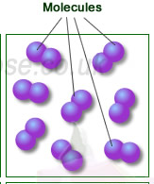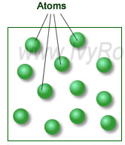  Drawing Molecules of elements:  - Molecules are represented by two or more circles  joined _____________  - Molecules of the ______ element are represented  by two or more circles of the same size and  color joined together  Drawing Compounds:  - 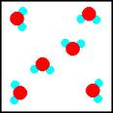Molecules of compounds are represented by two or more circles of ________ sizes and colors joined together
So What?! | Write a summary of what you learned today here and why it matters that you are the keeper of this knowledge:
“We Own This” (Guided Practice): Write down examples from our white-board practice here!

“I Own This” (Independent Practice):
- What is a compound?

- How is a chemical formula different from a chemical symbol?

- State if the following substances are elements or compounds.

  - NaCl
  - Ne
  - CO
  - C₆H₁₂O₆
  - Hg
  - KNO₃
  - Ni
  - Pb

  - H₃O

- Draw the atoms of the compound HCl.

- Create a Venn diagram of elements and compounds.

