Name:________________________Homeroom: __________ Date:___________ 2.1 + 2
All Matter is Made of Atoms Study Guide (SPI.9.1)
Part I: Matter
- What must anything that is considered matter have?

- What is the building block of all matter?
- Give three examples of things that are matter (one solid, one liquid, one gas).

- Give an example of something that is not matter.

Part II: Using Tools to Find Mass and Volume
- What measuring tools would you use to find the volume of an irregularly shaped key?

- What measuring tool is used to find the mass of an egg?

- What unit is volume usually measured in?

- What unit is used to measure mass?

For the following measuring tools (5-7), name them and state if they would be used to measure mass or volume.
5. 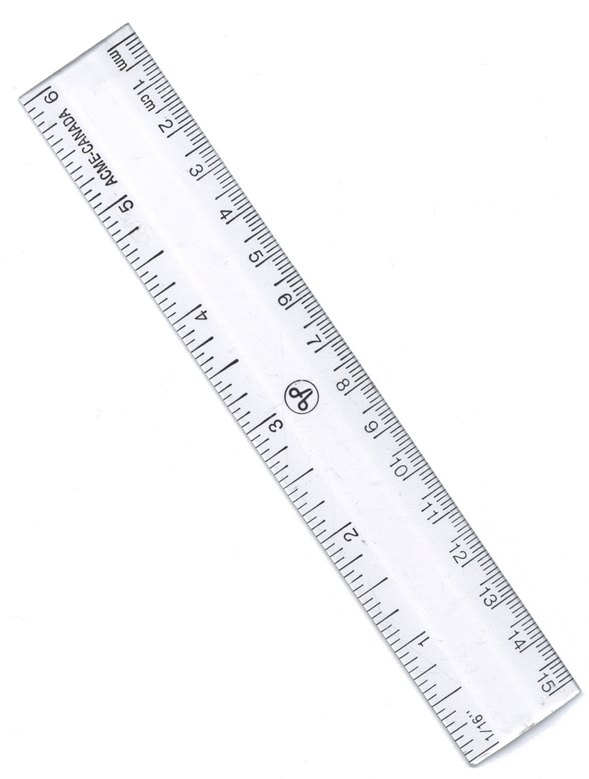 6. 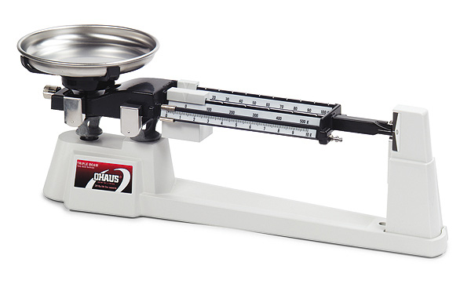 7. 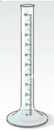

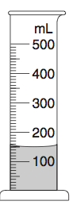

Use the image to the right to answer questions 8-12.

- What is the name of this measuring tool?

- What is it measuring?

- What is the unit used for measurement?

- What is the initial volume of the water?

- If I add a small seashell in, the water level rises to 200 mL. What is the volume of the seashell?
Part III: Parts of the Atom
- What is all matter made up of?

- Use the following words to fill out the diagram below: proton, neutron, electron, and nucleus.

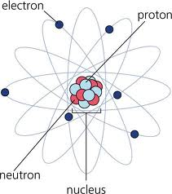

- Fill in the entire table below of the three subatomic particles.
Subatomic Particle | Charge | Location | Size
Proton
 | Negative

- What subatomic particles are located in the nucleus?

- What subatomic particle do you think would be the first to come in contact with another atom if they were to interact?

MAKE SURE YOU STUDY, IT MATTERS!! JUST LIKE YOU!

