Name: __________________________ Homeroom: ___________ Date:__________ **1.8**

**Scientific Notation Homework (MATH.2.3)**

**Part I: Converting Between Standard Form and Scientific Notation**



**Part II: Multiplying with Scientific Notation**

1) 2)

3) 4)

**Macintosh HD:Users:cjohnson:Desktop:Screen shot 2011-08-28 at 7.47.24 PM.png**

**Part III: Dividing with Scientific Notation**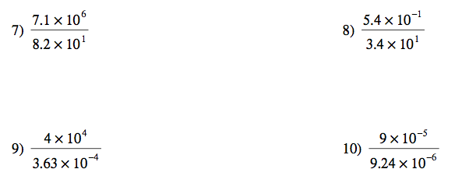

**Part IV: Using Powers (Exponents) with Scientific Notation**

1) (6 x 10-5)3 2) (6.3 x 102)-6

3) (5.21 x 10-5)2 4) (2.4 x 10-5)4

***Do you understand what we have learned in scientific notation so far?***