Name: __________________________Homeroom: ___________ Date:__________ 1.8

Multiplying, Dividing, and Squaring Numbers Using Scientific Notation (SPI.MATH.2.3)

Key Point | Notes
Scientific Notation | Scientific notation is a way of _______________________________  _____________________________________________________.  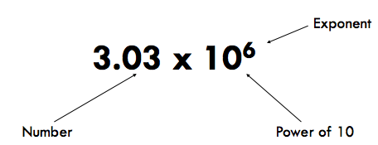  A number in correct scientific notation has ________________________  __________________________________________________________________________________________________________.
Exponents | - If the number is _______then the exponent is ________________; if the number is ________ then the exponent is ___________________.  - Every time you move the decimal to the RIGHT, exponent DECREASES by 1.  - Every time you move the decimal to the LEFT, exponent INCREASES by 1.
Multiplying in Scientific Notation | _______________ the numbers and ______ the exponents  Ex: (7.50 x 10⁵ ) * (6.1 x 10³ ) = 46 x 10⁸ = 4.6 x 10⁷
Dividing in Scientific Notation | Divide the ___________and SUBTRACT the __________________.  Ex: (7.50 x 10³ ) / (6.1 x 10⁵ ) = 1.2 x 10⁻²
Using Powers in Scientific Notation | Square the numbers and MULTIPLY the exponents  Ex: (7.50 x 10³ )²= 7.5² x 10^{3x2} = 56.25 x 10⁶ = 5.62 x 10⁷
How Do I Do This in My Calculator? | - 1.) Begin by placing an open parentheses around your number  - 2.) To get a base at a power of 10, hit the 2nd button and then the, button. You should see an uppercase E show up on your screen. This is the equivalent to x10.  - 3.) After the E, type the power that the number is raised to  - 4.) Close the parentheses  - 5.) Use whichever operations (+, -, *, /, ^) that the problem requires.  - 6.) Repeat steps 1-4 for other number  7.) Hit enter to solve
So What? | Write a brief summary of what you learned here:

“I Own This” (Independent Practice):
You may use a separate sheet of paper and a calculator for your calculations.

- Why do scientists use scientific notation?

- Bill Gates-so wealthy his worth has to be classified using scientific notation
Salary (standard notation): 968,799.00
Scientific Notation:
Net worth: $40,000,000,000.00
Scientific Notation:

3. Simplify (3.9 x 10⁹)²

4. (1.67 x 10²⁵ )(8.84 x 10²⁴⁾

5. 6.7 x 10⁶
2.3 x 10⁹

6. Simplify (8.8 x 10⁹)⁵

7. (6.78 x 10² )(8.42 x 10⁻¹⁰)

8. 9.7 x 10⁻²
2.1 x 10⁶

