Name: __________________________ Homeroom: ____________ Date:________ 1.7

Interpreting a Qualitative Graph Representing a Contextual Situation(SPI.MATH.1.2)

Key Points | Notes
Quantitative  Vs. Qualitative Data | Quantitative Data Qualitative Data  - ______________ data - Measured - Quantitative Quantity - Not numerical data - Information that is __________ - Can be just as important as quantitative data - Qualitative Quality
Increase
Decrease
Constant
Constant Rate

“We Own This” (Guided Practice):
With your partner at your table, come with a story to describe the following graph. Make sure you have one independent and one dependent variable. Be creative to explain the changes.
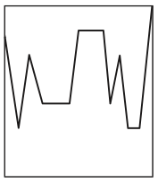
“I Own This” (Independent Practice): **This should be completed on a separate piece of paper!**
For the following graphs (A-C), create a contextual story with two variables to explain them.
A. B. C.
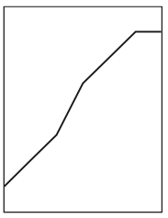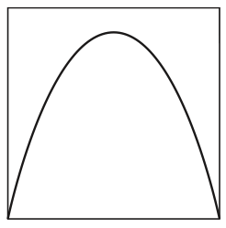

Graphing From Stories. Neatly, create a graph for each story below. Make sure to label each axis.
- On average, people with more education earn more. Graph years of education versus income.

- A car blasting music is approaching from the distance. As it nears you, the music gets louder and louder. After it passes, the music fades until the car is far in the distance. Graph loudness versus distance between you and the car.

- When I-pods go on sale, more people want to buy them. Graph price versus number of people who want to buy I-pods.

- A cup of tea is extremely hot when you pour it. Graph temperature versus time.

- You get in a fight with a lion. Graph the number of bites the lion takes out of you versus time.

- You begin the year with $400 in your checking account. Each month you deposit $50 extra in your bank account. Graph your total money versus time.

- Create a scientific experiment with one independent and one dependent variable and graph their relationship.

“Own It Even More” (Early Finishers):
