Name: __________________________Homeroom: ____________Date:__________ 1.5

Types of Graphs to Display Data: Bar Graphs, Line Graphs, Pie Charts, and Scatterplots (SPI.INQ.3)

Key Points | Notes
Data | Data are information in the form of ________________ and/or ________________________.
Data Tables | - Data tables are used to display our data. In a data table, the independent variable is on the _______ and the dependent variable is on the right.  - You need to make sure that you include your __________!  Studying vs. Assessment Score  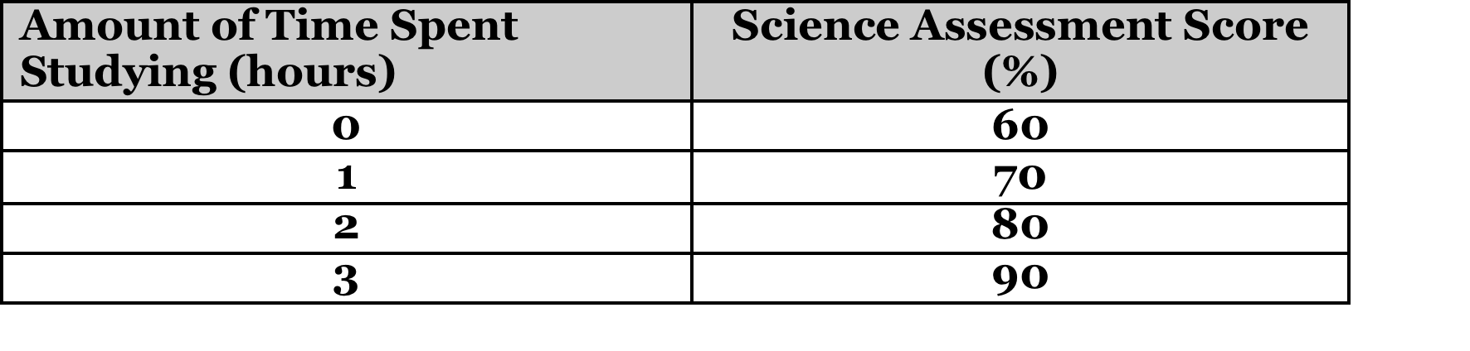
Charts and Graphs | •We use ___________ and ___________ to help us _________________ our results and conclusions  •Sometimes, complicated information complicated information can be made easier to understand by providing an ___________________________.
Bar Graph | •Usually a bar graph is used to ____________________________________.  •Useful for comparing data of several groups
Pie Chart (Circle Graph) | •Pie charts are used to show _____________________ of a whole at a set __________ in time  •Pie charts show part: whole relationships  •The “pie” is divided into different “pieces” of different sizes  •The size of each piece represents a fraction or a percentage of the whole (100%)
Line Graph | •A line graph is usually used to show how something ___________________  ___________________________________________________________.  •They have ______ different _______ that each show a value for a variable  •Within a line, graph, a point is plotted at each place where the values of two variables intersect  •A ________ is used to connect _____ points  •Line graphs are best used to show ____________ in data more clearly than tables
Titling Graphs | A graph title:  - Must communicate the dependent and independent _____________  - Can be presented in the form “Y versus X”
Labeling Axes in Graphs | - Independent (manipulated) variable is written along the ___________________ axis (X- axis)  - _______________ (responding) variable is written along the vertical axis (Y axis)  - Units on any variables should be included in _________________ (kg)
Plotting Data Pairs as Points | - Make sure the data table is in (X,Y) form  - Select the first pair of values from the data table (X and Y).  - Draw a light, dashed line up from the number on the X axis and over from the number on Y axis.  - Where these light lines cross, put a dark point.  - Repeat for the next pair of points.
So What?? | - Bar graphs are used to compare groups  - Pie charts (circle graphs) are used to show part to whole relationship (percentages)  - Line graphs are used to show trends over time. They are used to see relationships that exist between your independent and dependent variables. These graphs are the most frequently used graphs in science.

